12 Centennial Farms and Ranches Recognized by
History Colorado and Colorado Department of Agriculture
Redefines, Expands and Celebrates Colorado Agriculture’s Legacy and Culture

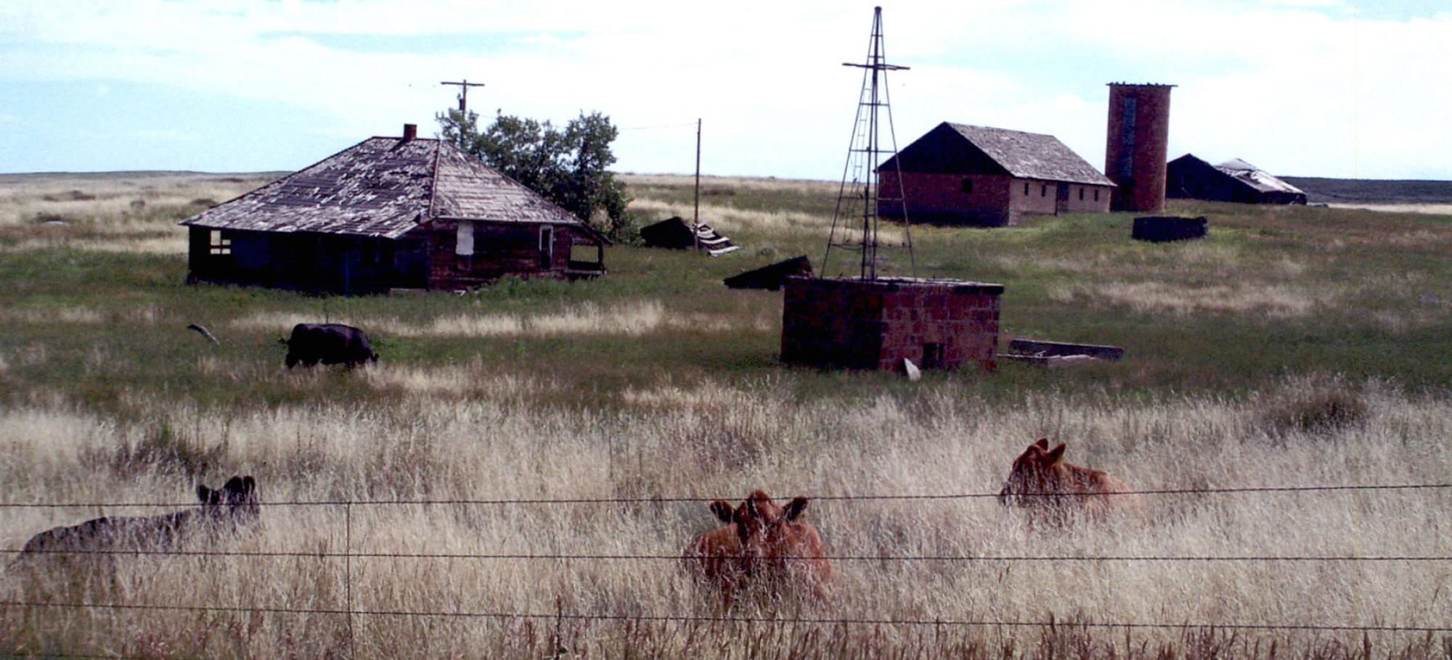

historycolorado.org | #HistoryColorado

PRESS CONTACT FOR IMMEDIATE RELEASE
Grace Markley, Philosophy Communication
720.421.9633 | grace@philosophycommunication.com

DENVER, Aug. 22, 2022 -- History Colorado and the Colorado Department of Agriculture have expanded their annual Centennial Farms and Ranches commemoration to include categories that now recognize the cultural and commercial sides of agriculture’s heritage, in addition to Colorado ranch and farm family operations who are honored for their longstanding commitment to agricultural values. On Aug. 26, at the Colorado State Fair in Pueblo, 10 recipients will receive honors that celebrate at least 100 years of resilience, perseverance and sustainability; and most notably, that acknowledge the contributions of agribusinesses, community land practices and families, many of which may have been excluded from passing down land because of discriminatory policies and practices. In addition, two Agricultural Legacy Awards will be given for the first time, recognizing professionals and communities who have created positive cultural shifts for the industry.

The Centennial Farms and Ranches program not only illustrates the significance of agriculture to the development and history of Colorado, but also shows how vital these farms, ranches, businesses, practices and people are to the well-being of Colorado today. Centennial Farms and Ranches honorees elevate Colorado agriculture by providing open space and food; supporting Colorado’s economy; and serving as an important reminder of our state’s many cultures and heritages.

“We draw strength from the rural stories of endurance and persistence from the farmers and ranchers who personify Centennial Farms and Ranches, as well as some of the cultural practices that have helped innovate and sustain agriculture. We are thrilled to celebrate the combination of Colorado history and culture,” said Dawn DiPrince, History Colorado’s Executive Director and State Historic Preservation Officer. “That is why we have expanded the program to add even more stories – especially from ag families who, for political or economic reasons, could not own land -- and recognize new categories of ag contributors who are also preserving important pieces of our state’s commercial and cultural history; and who also define the legacy of ag. Centennial Farms and Ranches is more inclusive than ever, as forward is the only well-grounded and well-timed direction to go. And that’s good news for all of us.”
Currently in its 36th year, the Centennial Farms and Ranches program is celebrating farmers and ranchers’ heritage and perseverance through more than 100 years of changes and challenges in ag. With its expansion to include non-owners and agribusinesses, the Colorado program breaks new ground in how states commemorate history and agriculture – and how they combine both legacies.

“Agriculture is many things, but one thing it is for all of us is the sense of deep roots in the love of the land. The Centennial Farms and Ranches recognition ceremony honors the depths of these roots. Century-long survival in agriculture requires an alchemy of past and future, innovation plus generational intuition, and technology combined with ancestral land practices,” said Colorado Commissioner of Agriculture Kate Greenberg. “This program highlights the statewide impact and resilience of farmers, ranchers and agricultural businesses, of cultures and communities. Even with the pressures of growth,drought and climate change, and uncertain economic conditions, farmers, ranchers and all who work in agriculture feed us, no matter what. It is an honor to get to celebrate them.”

History Colorado, the Colorado Department of Agriculture, and the Colorado State Fair have partnered to honor Colorado’s agricultural heritage through the Centennial Farms and Ranches program since 1986, when the program was initiated by former Governor Richard Lamm. More than 644 families, agribusinesses, and cultures have been recognized by the program. Collectively, they represent the powerful history of those farms and ranches who have sustained, supported and innovated for more than 100 years.

About the 2022 Centennial Farms and Ranches Honorees
On Aug. 26, the program will recognize 10 honorees from 10 different counties in four categories associated with the agricultural history of the State of Colorado. These honorees join a prestigious list of past recipients who have also shown their dedication and commitment to the thriving agriculture business in Colorado. Each honoree will receive a certificate signed by Colorado Governor Jared Polis, Dawn DiPrince and Commissioner of Agriculture Kate Greenberg; signs to proudly display on their properties; and state proclamations for each family.

The honorees follow:
- Centennial Farms or Ranches that have belonged to the same family for at least 100 years, and that is currently a working farm or ranch:
- Vermillion Farm (Elbert County), since 1914
- Sonnenberg Farm (Logan County), since 1919
- Schmeeckle Farm (Weld County), since 1917
- Koeller Farm (Kiowa County), since 1921
- Dorenkamp and Harper Ranches (Prowers County), since 1920
- Curtis Ranch (Morgan County), since 1914
- Blake Ranch (Routt County), since 1905
- Johnson Reaphook Ranch (Mesa County), since 1900
- Centennial Families with ag experience in Colorado that spans 100 years or more, not necessarily as land owners (NOTE: New category):
- Hirakata Farm (Otero County), since 1915
- Centennial Farmer or Rancher, an individual who is 100 years of age (or older) and who has spent their life in agricultural pursuits within the State of Colorado, not necessarily a land owner (NOTE: New category):
- No honorees this year
- Centennial Agribusiness that has been in operation for 100 or more years and primarily serves that ag community in Colorado (NOTE: New category):
- Colorado Farm Bureau Federation (Arapahoe County), since 1919

About the 2022 Agricultural Legacy Award Recipients
On Aug. 26, for the first time in the program’s history and to be continued in the future, two Agricultural Legacy Awards will recognize extraordinary contributions to the practice of Colorado agriculture. Recipients can be an ag professional and/or an ag practice or culture. This year’s Agricultural Legacy Award recipients are:

- Colorado State Historic Preservation Officer Agricultural Legacy Award
Living Culture and Practice of Acequia Communities – awarded to the Sangre de Cristo Acequia Association in San Luis Valley, which represents more than 70 acequias
- Acequias are a unique and centuries-old cultural and legal institution that have uniquely shaped Colorado’s agriculture. Acequias are community-operated irrigation systems that originated in the Middle East, were brought to Spain by the Moors, and then imported to the Americas by the Spanish over four centuries ago. In all of North America, acequias can only be found today in four Colorado counties (Conejos, Costilla, Huerfano, and Las Animas) and New Mexico. The unlined ditches of an acequia system replenish aquifers and support diverse ecosystems – and continue to provide water to Colorado farms that support hundreds of families.

- Colorado Commissioner of Agriculture Legacy in Agriculture Award
In Memory of Bob Sakata
- Bob Sakata, who passed away this year at the age of 96, was known for his farming contributions and leadership in Colorado agriculture; but he had challenging beginnings. He was born in California, was sent to an internment camp in Topaz, Utah as a teenager in 1942; and then gained early release through his work on a dairy farm in Brighton, Colo., where he was able to raise his family and grow his produce farm from 40 to 3,000 acres. Later, he was recognized nationally for changing the sweet corn industry with innovations in seed development and consumer packaging. Sakata’s outstanding contributions to Colorado agriculture were marked by his in his early years, as well as his hard work, stewardship, and leadership in the community, state, and country.

About History Colorado
History Colorado is a division of the Colorado Department of Higher Education and a 501(c)3 non-profit that has served more than 75,000 students and 500,000 people in Colorado each year. It is a 143-year-old institution that operates eleven museums and historic sites, a free public research center, the Office of Archaeology and Historic Preservation, and the History Colorado State Historical Fund (SHF), which is the nation’s largest preservation program of its kind. More than 70% of SHF grants are allocated in rural areas of the state.

History Colorado’s mission is to create a better future for Colorado by inspiring wonder in our past. We serve as the state’s memory, preserving and sharing the places, stories, and material culture of Colorado through educational programs, historic preservation grants, collecting, outreach to Colorado communities, the History Colorado Center and Stephen H. Hart Research Center in Denver, and ten other museums and historic attractions statewide. History Colorado is one of only six Smithsonian Affiliates in Colorado. Visit HistoryColorado.org, or call 303-HISTORY, for more information.
About the Colorado Department of Agriculture
The Colorado Department of Agriculture exists to support the state's agriculture industry and serve the people of Colorado through regulation, advocacy, and education. Our mission is to strengthen and advance Colorado agriculture, promote a safe and high-quality food supply, protect consumers, and foster responsible stewardship of the environment and natural resources. Learn more at ag.colorado.gov.
A division of the Colorado Department of Agriculture, the mission of the Colorado State Fair Authority is to celebrate Colorado’s vibrant and diverse agricultural industry and culture by creating an entertaining, inspiring, and educational inter-generational experience.
Interview Requests
For interview requests with Dawn DiPrince, executive director of History Colorado, or Kate Greenberg, Colorado Commissioner of Agriculture, please contact Grace Markley at Grace@PhilosophyCommunication.com or 720-421-9633.

# # #

